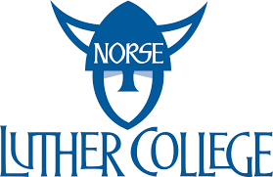

The Tolland Scholarship

The Tolland Scholarship is awarded to students from MHHS attending Luther College their freshman year.

The award is $2,500 and does not require an additional application.

